Support in Reading with Isaac Wells—The Core Collaborative
Working on Guided Reading will build a strong vertical connection K-5 and the work with Comprehension and Collaboration will do the same for Secondary Teachers.
The connection K-12 is the focus on increasing students’ independence and ensuring that readers can answer the three feedback questions: Where am I? Where am I going? How am I getting there?

Zoom Kick-Off: 4pm to 5pm Grades K-5 and 5pm to 6pm Secondary
Monday October 22nd: Kick off to set the purpose of the Zoom meetings, share the plan, and introduce the resources

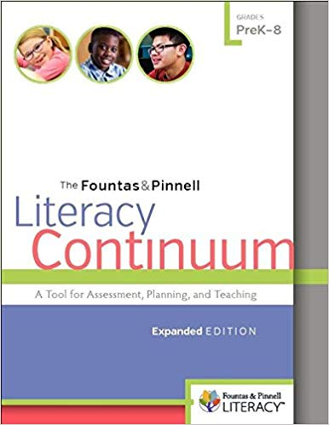 Resource for Grades K-5 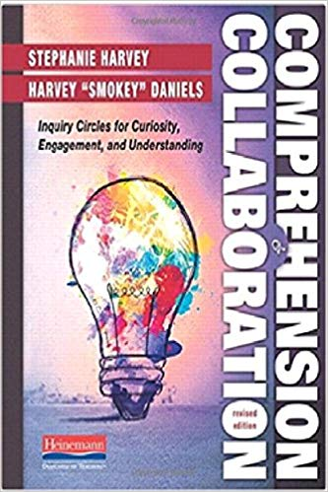 Resource for Secondary

All other sessions 8am to 10am—Secondary, 10am to Noon—Grades 3-5, 1pm to 3pm—Grades K-2
November 13th: Navigating the resources and providing the understanding and practical examples necessary for teachers to try out strategies before our next session
January 15th: Using our resources and making connections to celebrations and questions from participant evaluations to support all participants in implementation—describe what success looks like for students and teachers
February 25th: Using our resources and making connections to celebrations and questions from participant evaluations to support all participants in implementation—describe what success looks like for students and teachers
April 24th: Deeper implementation and looking ahead to next year—using participant responses to clearly describe the conditions for successful implementation in 2019-20

Please register at www.ecboces.org and be sure to register for YOUR SESSION:
8am to 10am Secondary Session: Collaboration and Comprehension
10am to Noon Grades 3-5: Literacy Continuum—Guided Reading
1pm to 3pm Grades K-2: Literacy Continuum—Guided Reading

ECBOCES Zoom: Click the Link below to join from PC, Mac, iOS or Android: https://ecboces.zoom.us/j/7197752342. If you are joining from a Zoom Presence Room, please click on Join on the iPad controller and enter 7197752342 and then click on Join on the keypad.

