Verizon Thinkfinity Overview Session

Facilitator’s Guide
Updated 9/3/09

Dear Verizon Thinkfinity Facilitator,

Thank you for your interest in Verizon Foundation’s Thinkfinity and your willingness to share your enthusiasm for its resources with others.

The following guide and its accompanying PowerPoint™ presentation include the major aspects of the Verizon Thinkfinity Web site and its resources. We suggest that you review them carefully prior to offering your session.

The guide offers basic information for what can be covered in a 15-20 minute overview presentation on Verizon Thinkfinity. Since we are often asked background questions ourselves during presentations, we have included additional information for each slide. If you find some things we missed are repeatedly being asked in your sessions, please let us know and we will be happy to add them.

Finally, most people like to walk out of any learning experience with something in hand to take home and look at for reference. We have, therefore, included a copy of a participant handout for distribution at the end of the session (page 9 in this guide).

The materials you are receiving in this package were designed to serve as a broad introduction to Verizon Thinkfinity. To ensure your participants’ expectations of the Overview Session are met, we encourage you to use these materials as presented here and encourage participants to view our course directory of training options for more information related to this program (http://www.thinkfinity.org/pd/request_training.aspx).

Again, thank you for sharing Verizon Thinkfinity others.

Sincerely,

Verizon Thinkfinity Professional Development Team
SLIDE TWO: Welcome to Verizon Thinkfinity’s Overview Session
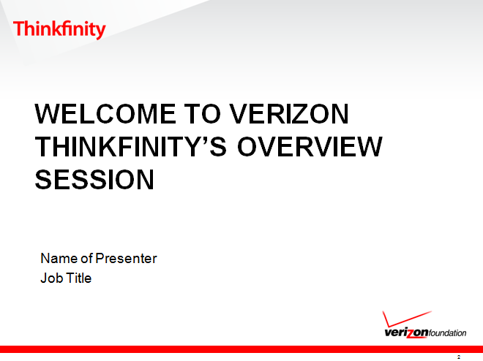 | Anticipated time on this slide: 1 minute
Suggested language-

“Good morning (afternoon or evening). My name is _____ and I will be presenting a wonderful program to you over the next 15 (or 20) minutes entitled Verizon Thinkfinity. This program is meant for educators, students, parents and afterschool practitioners.

But what is Verizon Thinkfinity?”

- Pre-session: Add your name, job title, audience, place and date to the presentation.
- Pre-session: Duplicate the last page of this guide for distribution to participants at the end of the session.
- Pre-session: Have slide projected while participants enter room.

SLIDE THREE: What is Verizon Thinkfinity?

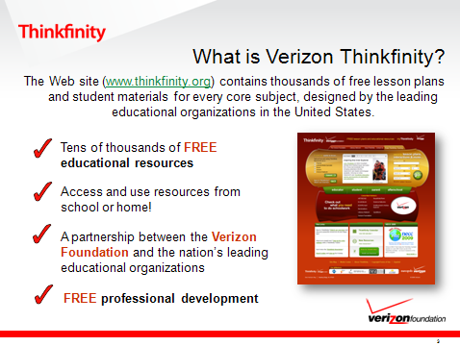 | Anticipated time on this slide: 1 minute
Suggested language-

“The Web site (www.thinkfinity.org) contains tens of thousands of free educational materials that can be used anywhere an Internet connection is available.

Verizon Thinkfinity is founded by the Verizon Foundation. Additionally, they have created a partnership between the nation’s leading educational organizations to provide high-caliber content and free professional development.

In today’s presentation, I will show you how Verizon Thinkfinity can help improve learning both inside and outside of the classroom.”

SLIDE FOUR: Why is Verizon Foundation Involved?

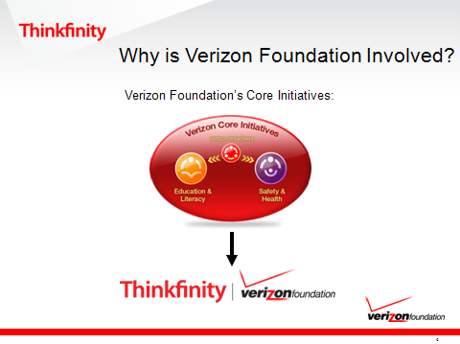 | Anticipated time on this slide: 2 minutes
Suggested language-

“We are often asked why the Verizon Foundation is involved with this program. The Verizon Foundation has a long history of being a leader in corporate philanthropy. Since 2000, the Verizon Foundation has invested more than $400 million in the United States and around the world to help others. In 2007, it awarded more than $67 million in grants to charitable and nonprofit agencies serving the needs of diverse communities. It does this to show its commitment to the communities Verizon serves and to generate goodwill.

Through the funding of this program, the Verizon Foundation is helping deliver resources to advance the knowledge and skills that are required of citizens in the 21st century, thereby making the future workforce ready and equipped to handle the challenges that lie ahead.”

SLIDE FIVE: Verizon Thinkfinity Content Partners

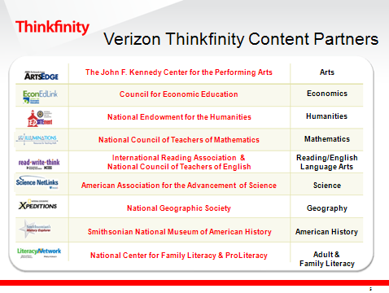 | Anticipated time on this slide: 1 minute
Suggested language-

“To ensure the success of this program, Verizon Thinkfinity has partnered with the nation’s leading educational organizations, such as (name a few-e.g.,. National Council of Teachers of Mathematics, etc.) to create the content you see featured on this Web site. They have also scoured the Internet for additional resources that are educationally appropriate and worthwhile for student use. Hence decreasing the amount of time educators, students, parents and afterschool practitioners are spending looking online for high quality content.”

SLIDE SIX: What Does Verizon Thinkfinity Provide?

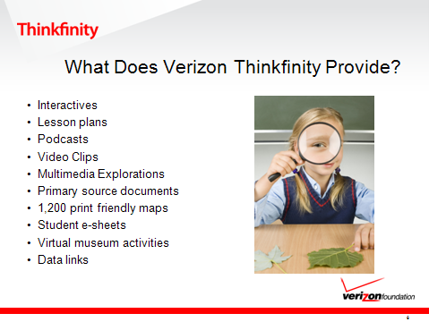 | Anticipated time on this slide: 1 minute
Suggested language-

“So what does Verizon Thinkfinity provide? It provides everything from interactives, lesson plans, podcasts and multimedia explorations, to name just a few!”

SLIDE SEVEN: Let’s Start Exploring
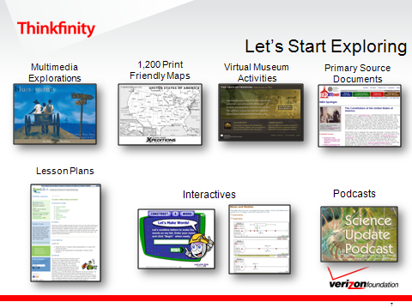 | Anticipated time on this slide: 4-9 minutes.
Suggested language-

“To better illustrate the dynamic nature of Verizon Thinkfinity’s resources, I am going to take a few moments to demonstrate one!”

Facilitator Note-choose appropriate resource based on the group with which you are sharing this presentation.

SLIDE EIGHT: How Can You Find Resources
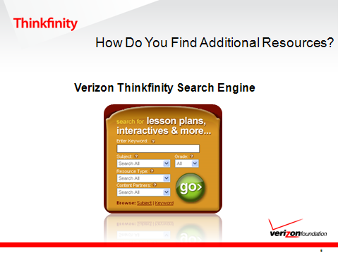 | Anticipated time on this slide: 1 minute
Suggested language-

“In this short presentation, I don’t have the time to show all of Verizon Thinkfinity’s resources. However, I encourage you to look for additional resources using the Verizon Thinkfinity Search Engine. Simply type your desired topic into their search engine and click go. You can also narrow your focus by subject, grade level, type of resource, or content partner if you prefer. Talk about a time saver!”

SLIDE NINE: Recently Added
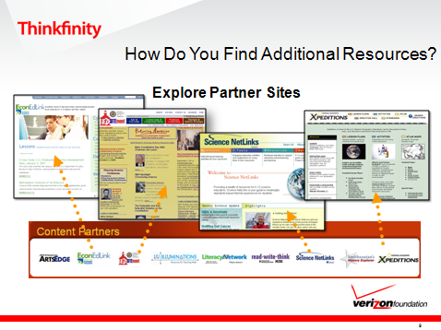 | Anticipated time on this slide: 1 minute
Suggested language-

“Besides utilizing the Verizon Thinkfinity Search Engine, I also encourage you to explore each Content Partner site individually. Once you click on any of the Partner logos, you will be taken directly to their Web page. From here you can access their lesson plans, interactives, Partner-reviewed Web links and more. Additionally, on each Content Partner site you’ll still have access to the Verizon Thinkfinity search engine.”

SLIDE TEN: Let’s Start Exploring
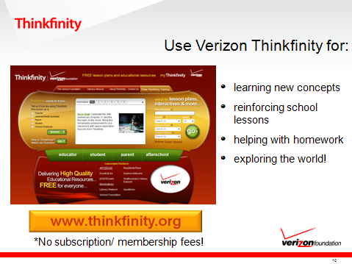 | Anticipated time on this slide: 1 minute
Suggested language-

“Verizon Thinkfinity can be used to help K-12 students learn new concepts, reinforce what is being taught in the classroom, help with homework assignments or just to learn more about the world around them.”

SLIDE ELEVEN: Additional Training Opportunities
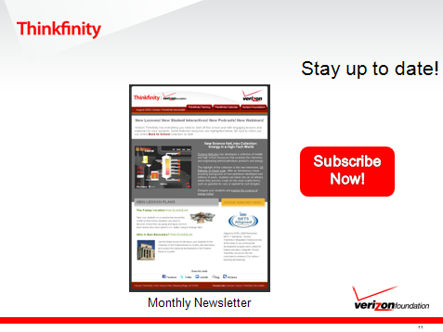 | Anticipated time on this slide: 1 minute
Suggested language-

“Every month Verizon Thinkfinity publishes a newsletter to keep you up–to-date on the latest program developments, resources, grant opportunities and more. You can view their past newsletters online, but I encourage you to sign up so that you don’t miss another exciting event or resource. All you need to do is enter your e-mail address and you’ll be added to their subscription list.”

SLIDE TWELVE: Additional Training Opportunities
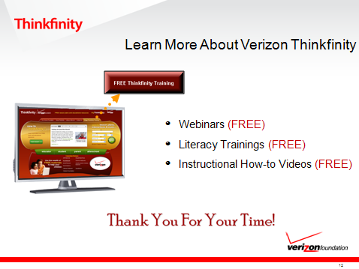 | Anticipated time on this slide: 1 minute
Suggested language-

“In this presentation, I have provided a brief overview to the Verizon Thinkfinity program. I encourage you to visit the FREE Training page on Verizon Thinkfinity. They provide a variety of training opportunities to help educators, parents and afterschool practitioners become more familiar with the program itself, the resources available through it and the Content Partners.

Thank you for attending this presentation. I hope you have a great morning (afternoon or evening) and you’ll enjoy the wealth of free resources on Verizon Thinkfinity.”



Content Partner Sites



















Verizon Thinkfinity Resources
Content Partners

American Association for the Advancement of Science
Council for Economic Education
International Reading Association
National Center for Family Literacy
National Council of Teachers of English
National Council of Teachers of Mathematics
National Endowment for the Humanities
National Geographic Society
ProLiteracy
Smithsonian National Museum of American History
The John F. Kennedy Center for the Performing Arts
www.thinkfinity.org
Free Educational Resources
- Standards-based lesson plans
- Student & Teacher Materials
  - Online
  - Interactive
  - Offline (printable)
- Partner-reviewed Web links

