Embedding a Word Document into PowerPoint

Previous Next
Problem Step 1: (11/9/2009 1:03:08 PM) User left click on "Object... (push button)" in "Microsoft PowerPoint - [ppt sample]"
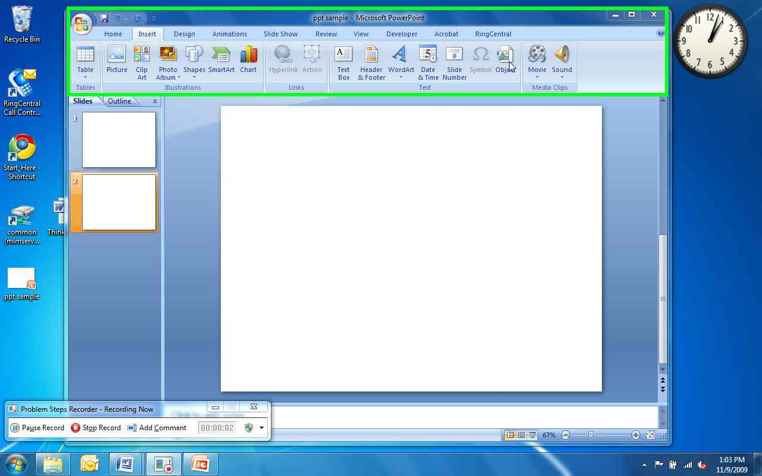

Previous Next
Problem Step 2: (11/9/2009 1:03:09 PM) User left click on "Object... (push button)" in "Microsoft PowerPoint - [ppt sample]"
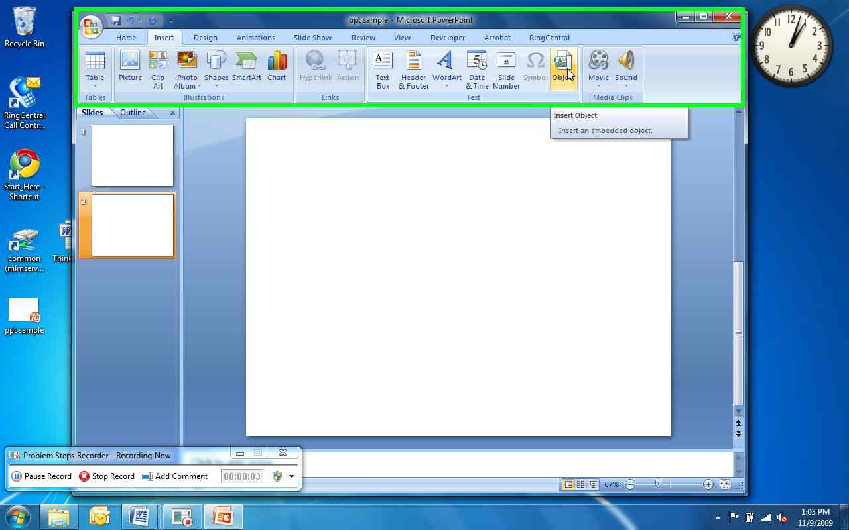

Previous Next
Problem Step 3: (11/9/2009 1:03:12 PM) User left click on "Create from file (radio button)" in "Insert Object"
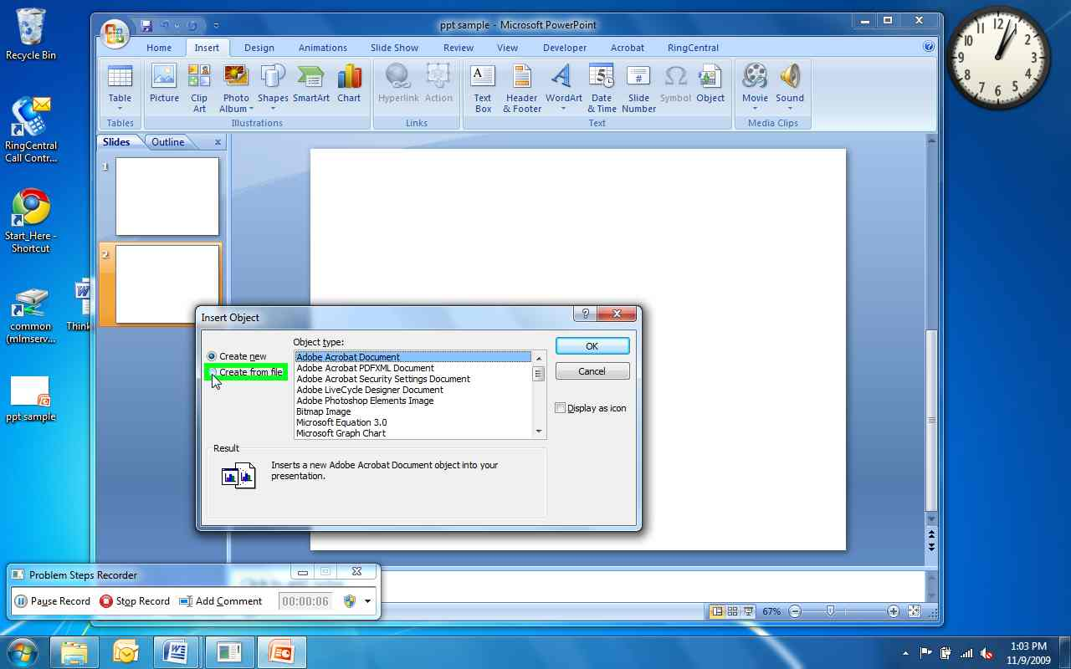

Previous Next
Problem Step 4: (11/9/2009 1:03:14 PM) User left click on "Browse... (push button)" in "Insert Object"
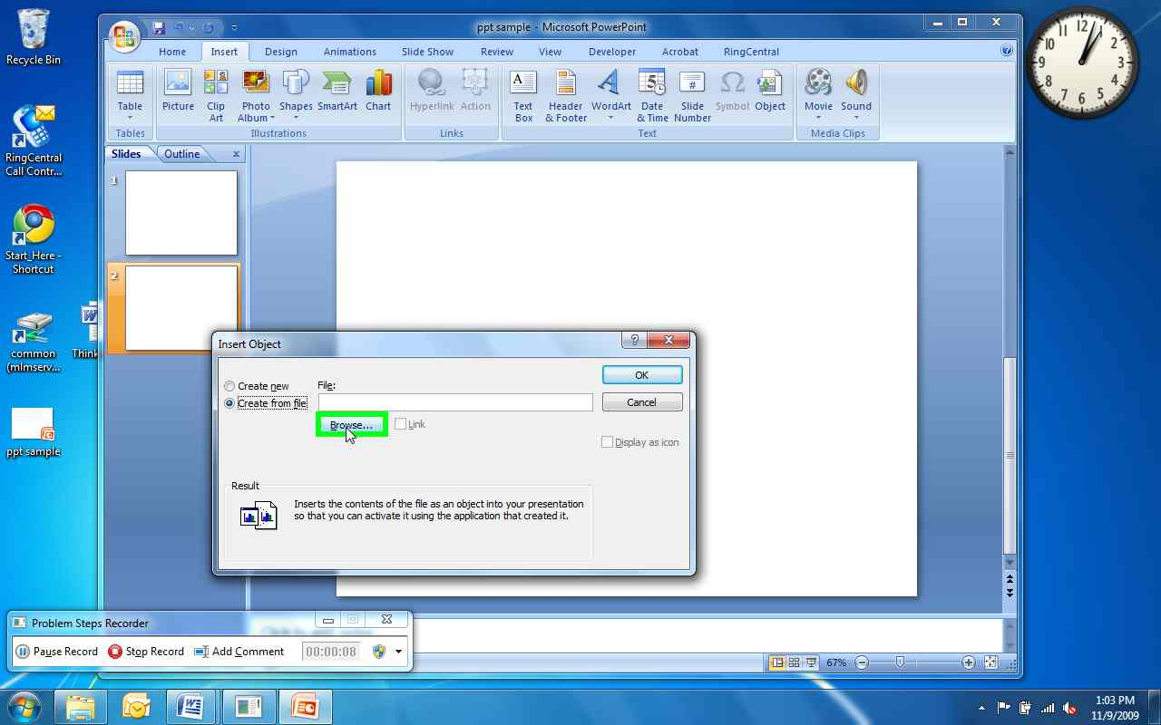

Previous Next
Problem Step 5: (11/9/2009 1:03:16 PM) User left click on "Desktop (outline item)" in "Browse"
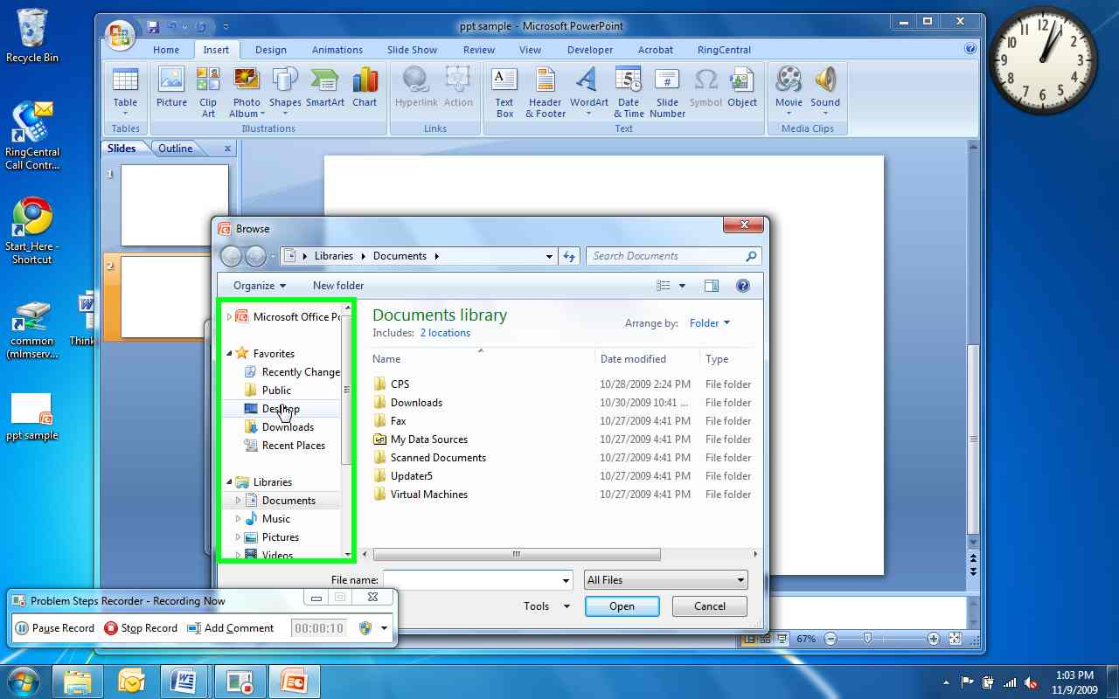

Previous Next
Problem Step 6: (11/9/2009 1:03:20 PM) User mouse drag start on "Position (indicator)" in "Browse"
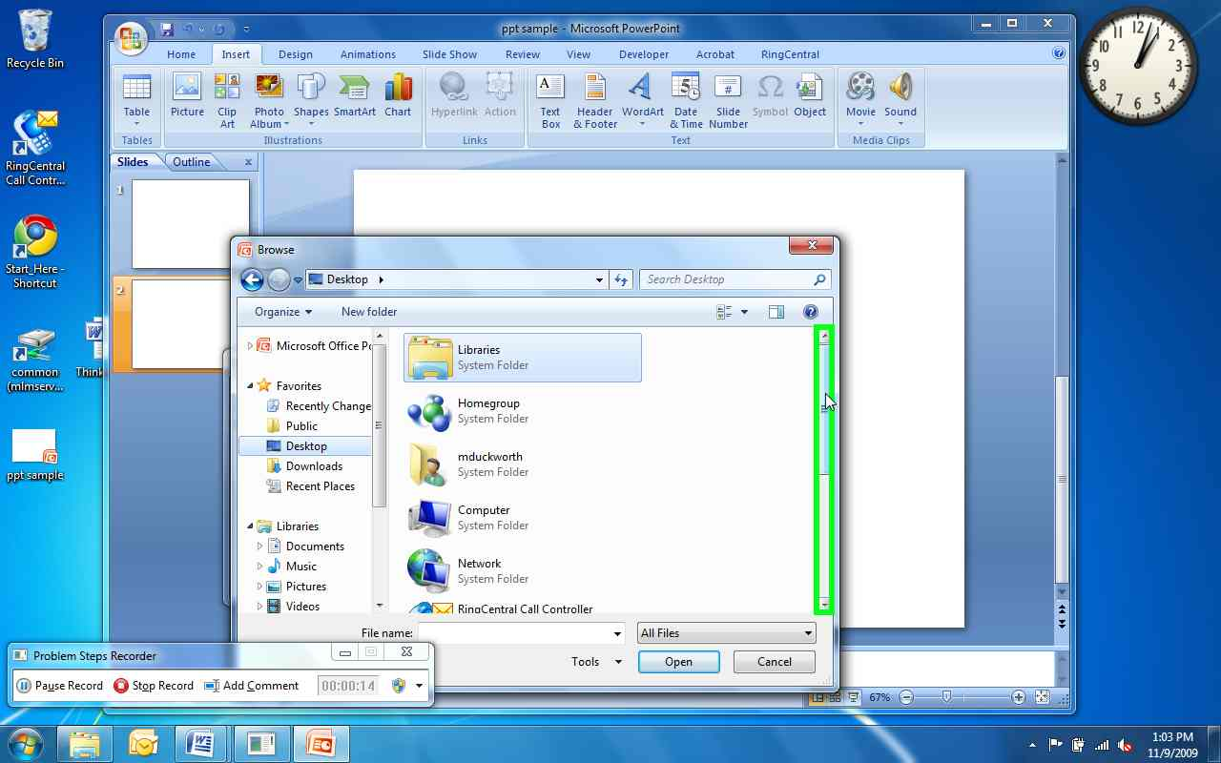

Previous Next
Problem Step 7: (11/9/2009 1:03:23 PM) User mouse drag end on "Position (indicator)" in "Browse"
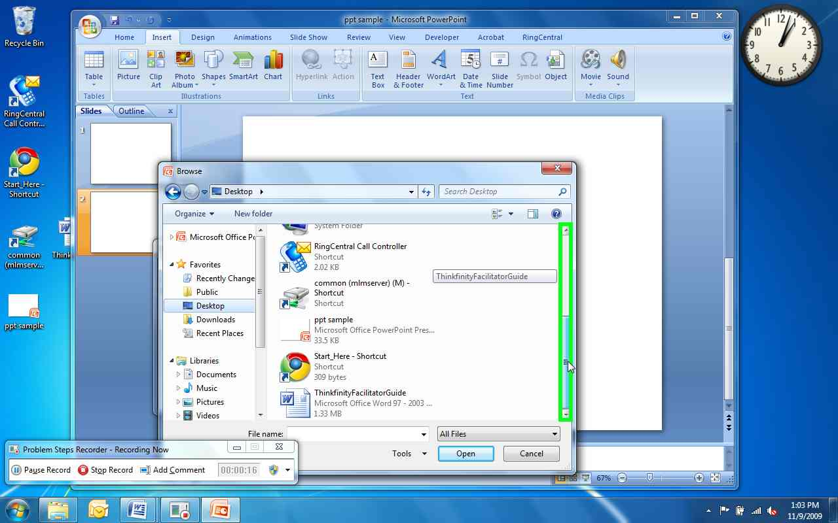

Previous Next
Problem Step 8: (11/9/2009 1:03:24 PM) User left click on "Type (editable text)" in "Browse"
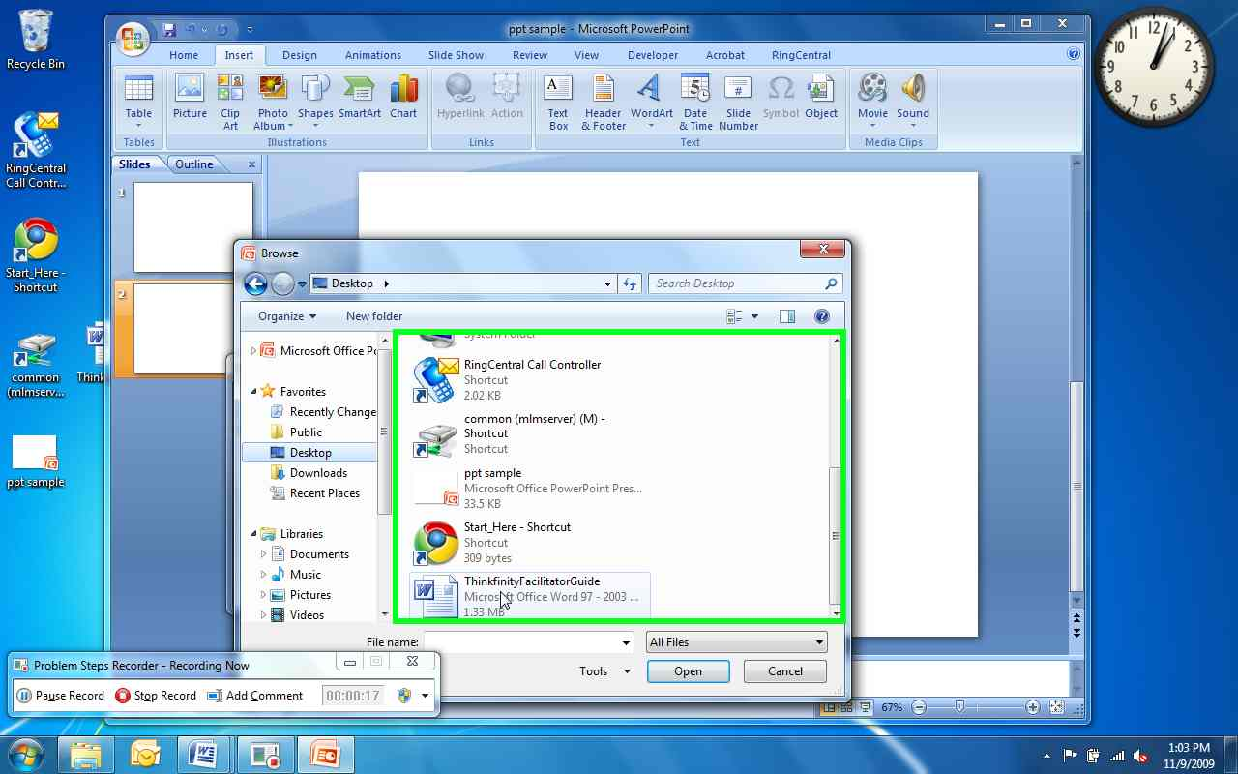

Previous Next
Problem Step 9: (11/9/2009 1:03:33 PM) User left click on "OK (split button)" in "Browse"
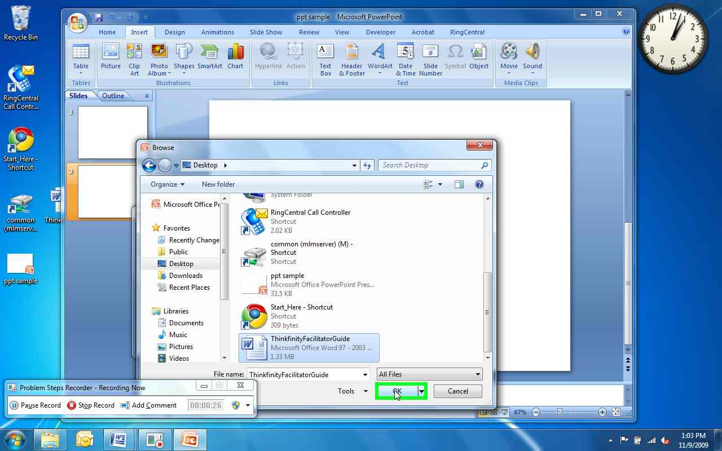

Previous Next
Problem Step 10: (11/9/2009 1:03:35 PM) User left click on "Link (check box)" in "Insert Object"
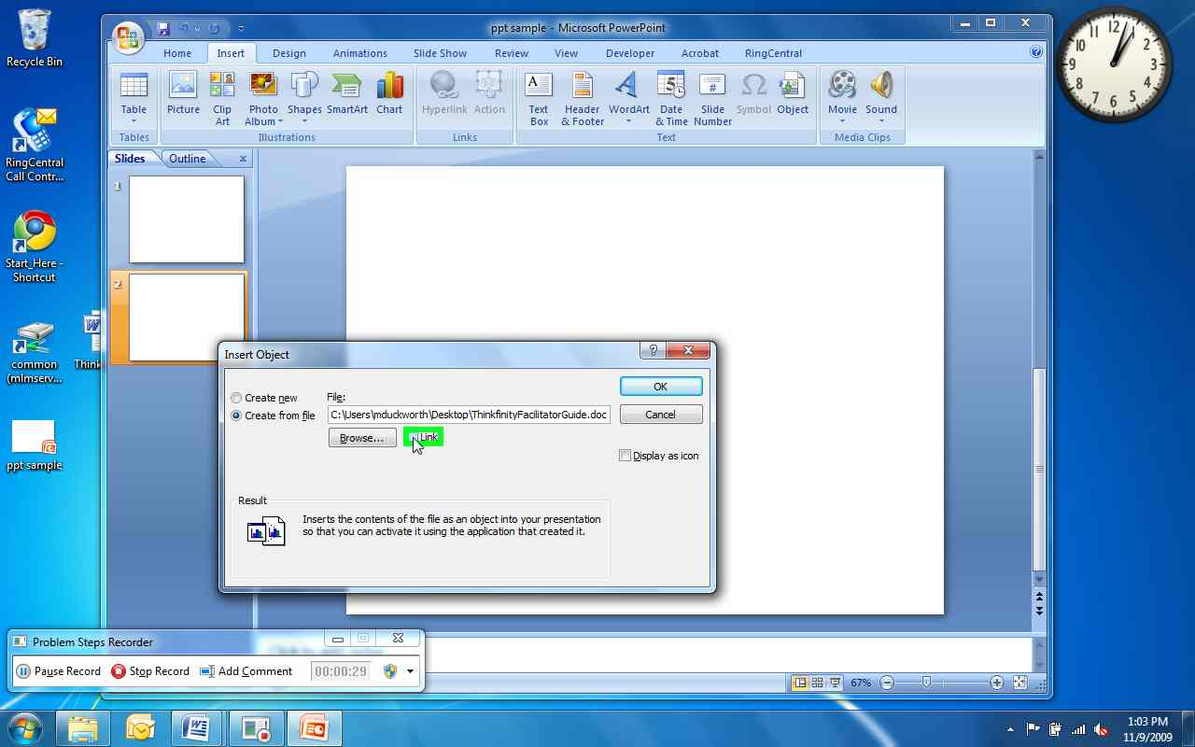

Previous Next
Problem Step 11: (11/9/2009 1:03:59 PM) User left click on "Display as icon (check box)" in "Insert Object"
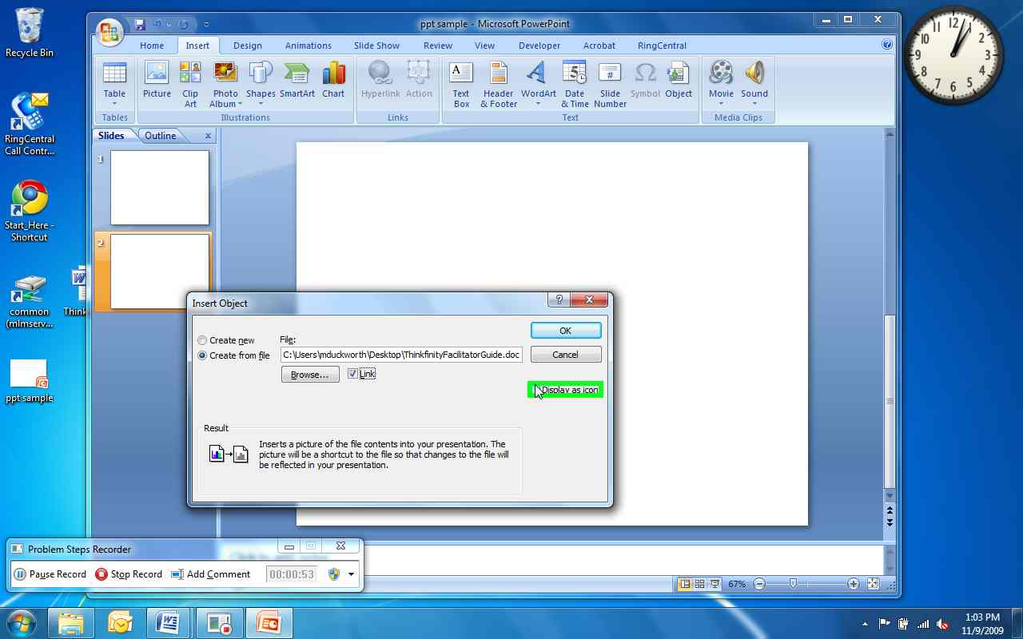

Previous Next
Problem Step 12: (11/9/2009 1:04:02 PM) User left click on "OK (push button)" in "Insert Object"
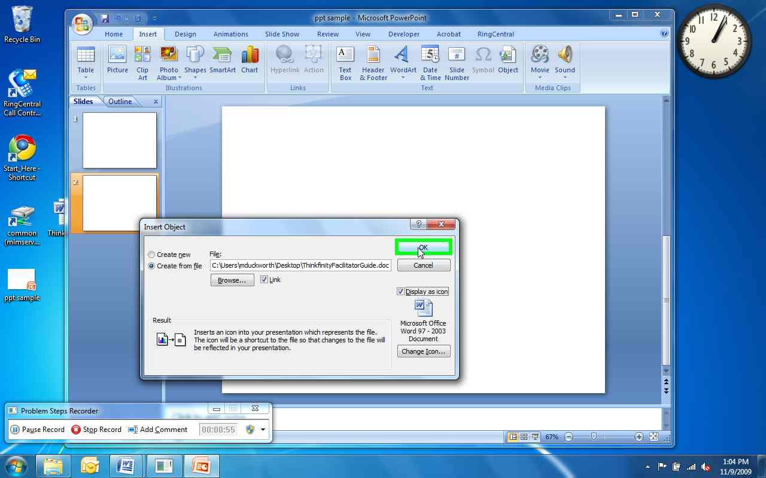

Previous Next
Problem Step 13: (11/9/2009 1:04:03 PM) User right click in "Microsoft PowerPoint - [ppt sample]"
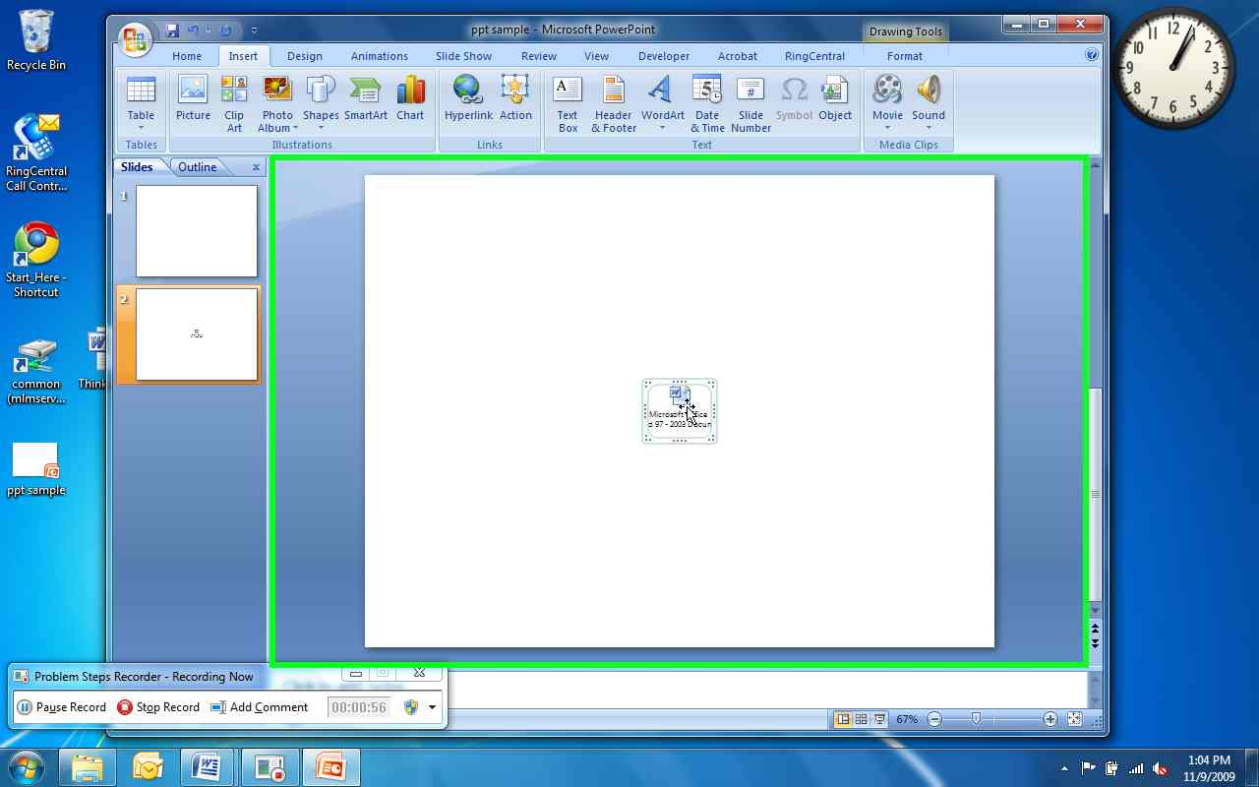

Previous Next
Problem Step 15: (11/9/2009 1:04:08 PM) User left click on "Action (push button)" in "Microsoft PowerPoint - [ppt sample]"
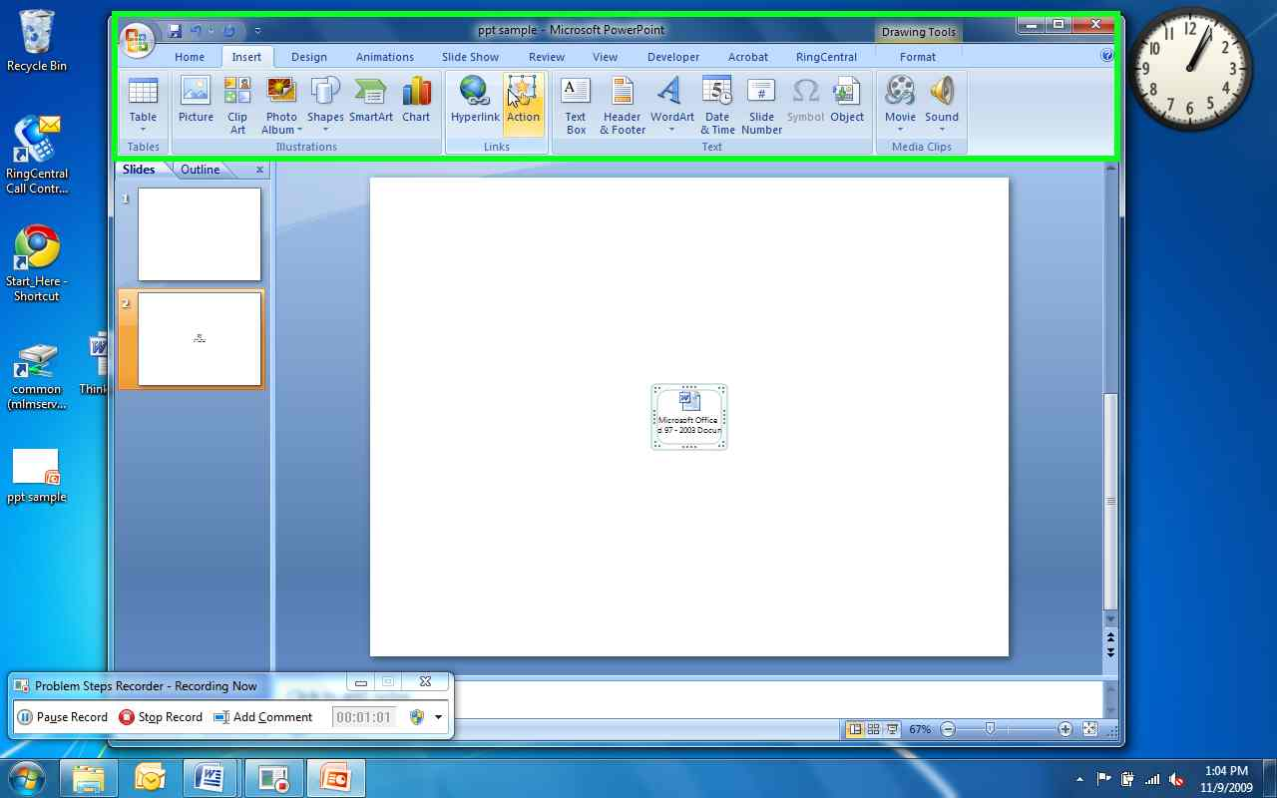

Previous Next
Problem Step 16: (11/9/2009 1:04:10 PM) User left click on "Object action: (radio button)" in "Action Settings"
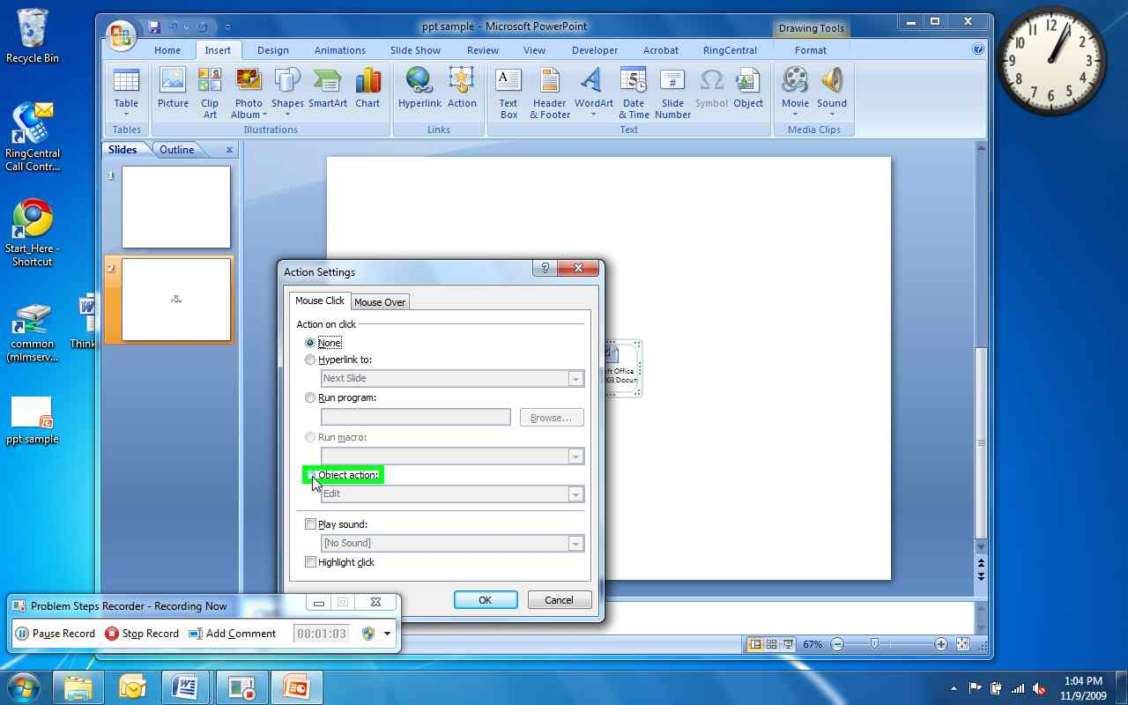

Previous Next
Problem Step 17: (11/9/2009 1:04:12 PM) User left click on "Open (push button)" in "Action Settings"
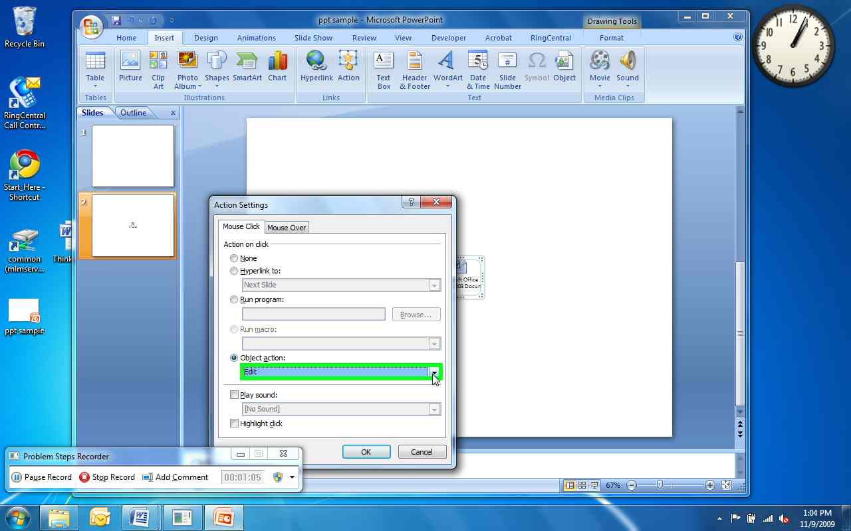

Previous Next
Problem Step 18: (11/9/2009 1:04:13 PM) User left click on "Open (list item)"
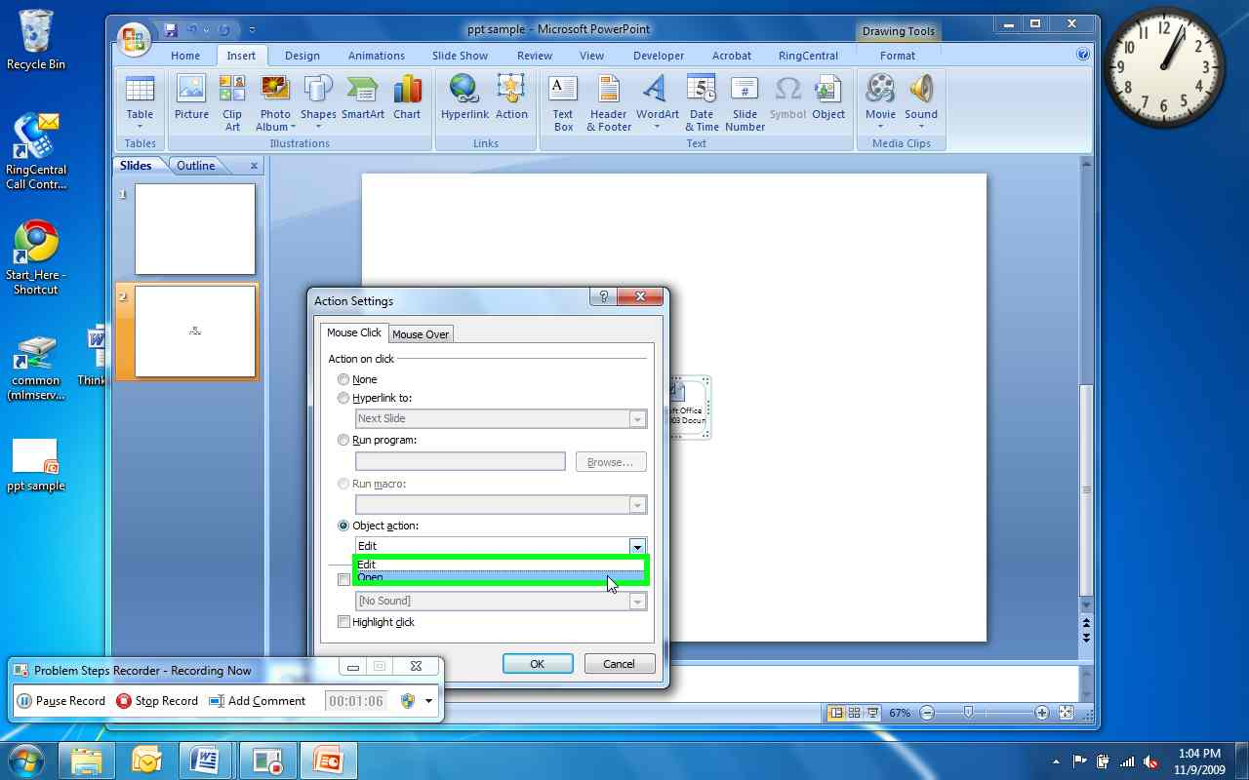

Previous Next
Problem Step 19: (11/9/2009 1:04:15 PM) User left click on "OK (push button)" in "Action Settings"
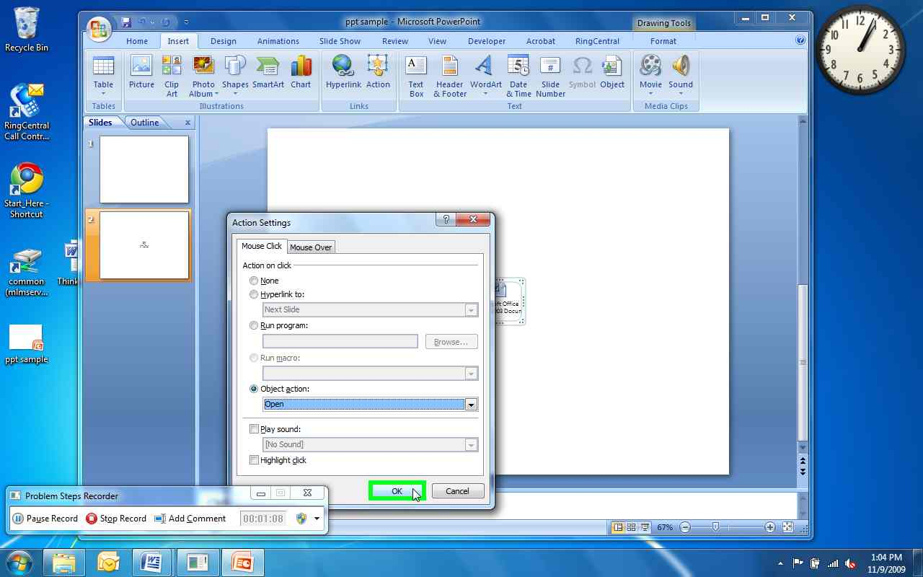
Return to top of page...

